**MediaStream Studios Enhances Security and Efficiency with IAM Access to Amazon S3 and EC2**

**Problem Statement:**

**MediaStream Studios**, a leading production company, faced the challenge of securely managing access to cloud-based solutions as their media production demands grew. The team needed to efficiently manage Amazon S3 storage and EC2 instances for storing and processing large media files. To address the risks of unauthorized access and resource misuse, MediaStream Studios implemented an IAM user system with tailored permissions, ensuring access was restricted to necessary tasks. This solution not only safeguarded sensitive media assets but also streamlined operations, allowing the company to securely and efficiently manage its growing production workflow.



**Pre-requisites:**

### 1. AWS Account Setup: [https://youtu.be/CjKhQoYeR4Q?si=ui8Bvk_M4FfVM-D](https://youtu.be/CjKhQoYeR4Q?si=ui8Bvk_M4FfVM-Dh)h

### 2. Understanding of IAM: <https://youtu.be/gsgdAyGhV0o?si=3qg-bULgkD4LXNvR>

3. Region Selection :<https://youtu.be/NQhH2kcKI5U?si=GwDI8Gx7oUot8PiT>

4. Basic Knowledge of Amazon Ec2: [EC2 basic concepts](https://aws.amazon.com/pm/ec2/?trk=29e2f26a-7577-451e-9d4d-ed0416a17cd3&sc_channel=ps&ef_id=:G:s&s_kwcid=AL!4422!10!72018238389337!72018763038666)

5. Basic Knowledge of Amazon S3: <https://youtu.be/tfU0JEZjcsg?si=F1QLN_QKvy753Zg8>

**Objective:**

The objective of this project is to create a secure and efficient IAM user management system for MediaStream Studios, enabling tailored access to specific AWS services such as Amazon S3 for media file storage and Amazon EC2 for rendering and processing tasks. The goal is to ensure that the production team can manage these resources with only the necessary permissions, while maintaining strict security standards to protect sensitive media content and streamline workflow.

**Tasks:**

1. Log in to the AWS Management Console and navigate to the IAM service.
2. Select the existing IAM user that requires access to AWS services.
3. Attach the necessary permissions for both Amazon S3 and Amazon EC2 directly to the IAM user.
4. Verify that the IAM user has appropriate access to S3 buckets and EC2 instances by testing the permissions.
5. Ensure that the process has been successfully completed by confirming the user’s access to the required services.

**Solution Development Procedure:**

1. **Log in to the AWS Management Console and navigate to the IAM service.**

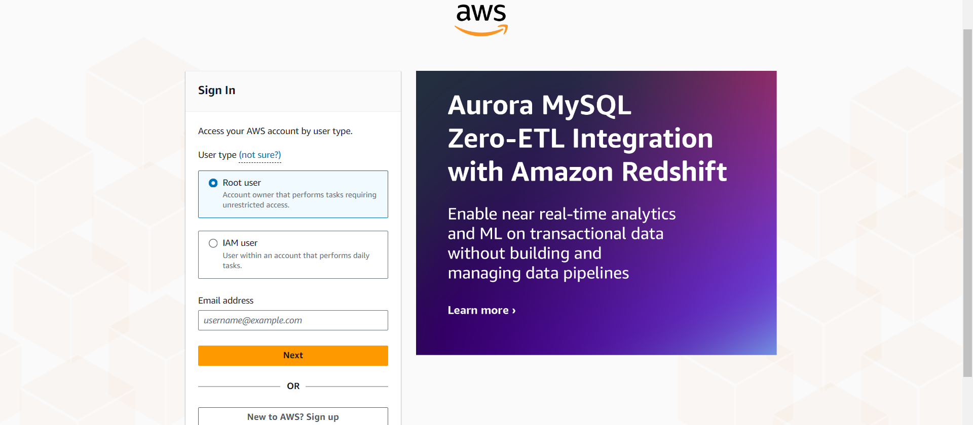

AWS sign-in page where the user selects between signing in as a **Root user** or an **IAM user**. This is the initial step for accessing the AWS Management Console.

- To give service permissions to an IAM user, log in as the Root User and navigate to the IAM service to attach the required permissions to the IAM user.

- While using the Root User is possible, it is generally recommended to use an IAM user with administrative privileges for day-to-day tasks to follow AWS security best practices.

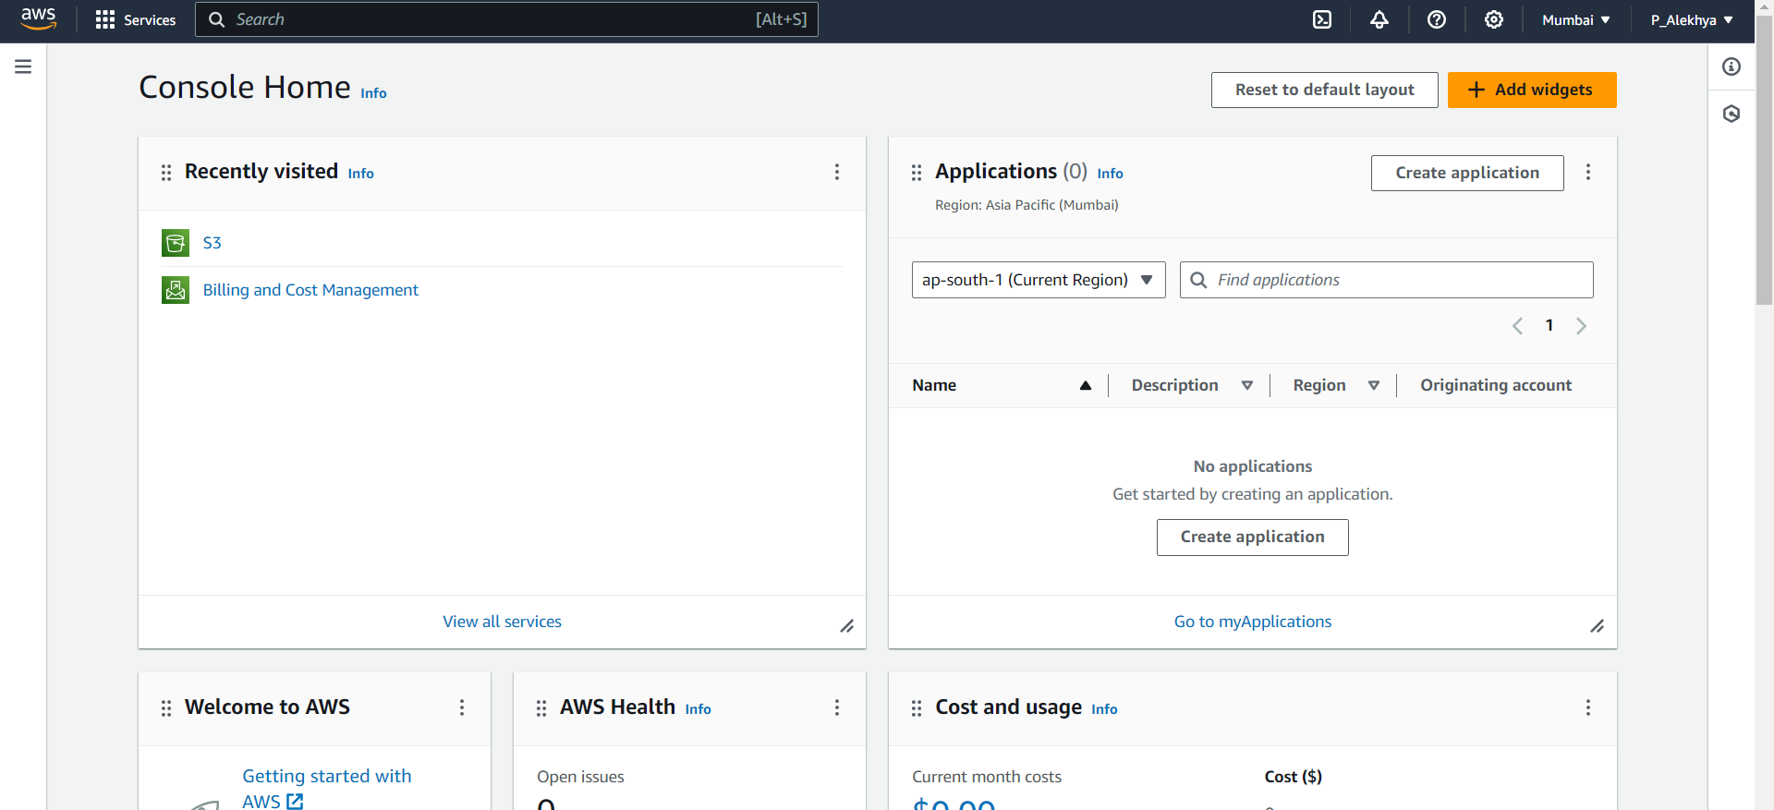

AWS Console Home page after login, displaying recently accessed services , along with an overview of the account’s activities.

* By navigating to the search bar ,we could find desired services.

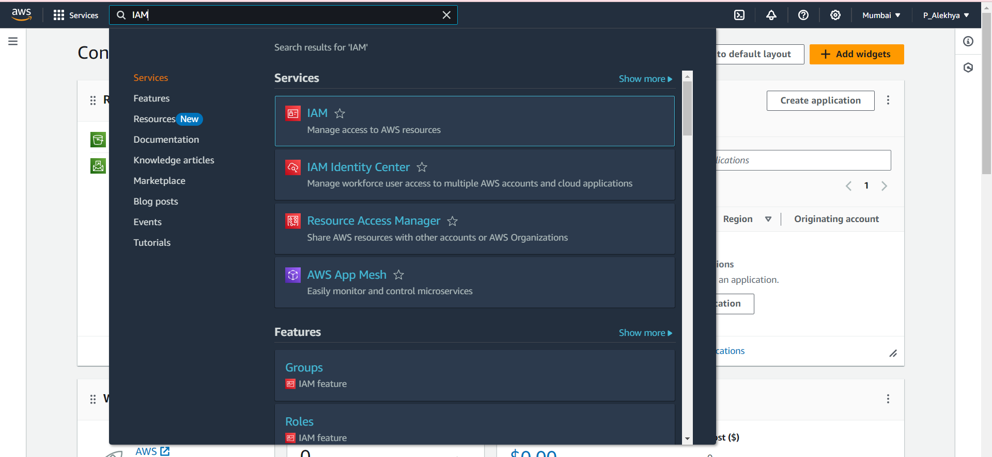

AWS search bar being used to look for **IAM** (Identity and Access Management) services. This enables quick navigation to the IAM dashboard.

* Select IAM Service ,which is at the top.

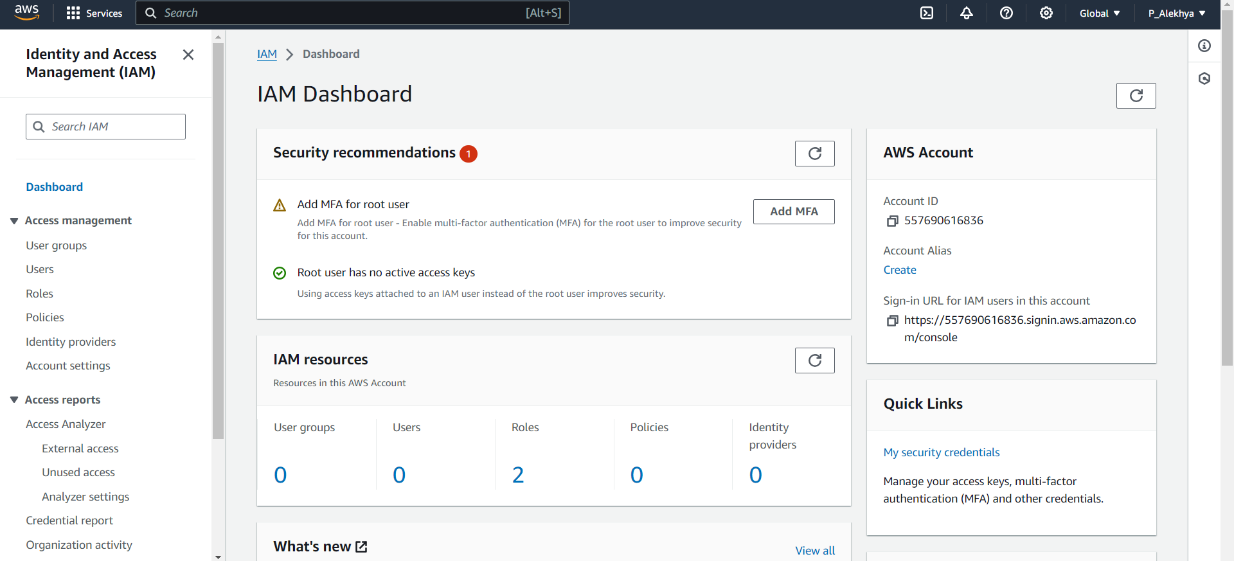

The **IAM Dashboard**, showing important security recommendations, such as enabling MFA for the root user, and displaying an overview of existing IAM resources like users, roles, and policies.

* Click on Users,to give services access to an IAM User.

1. **Select the existing IAM user that requires access to AWS services.**

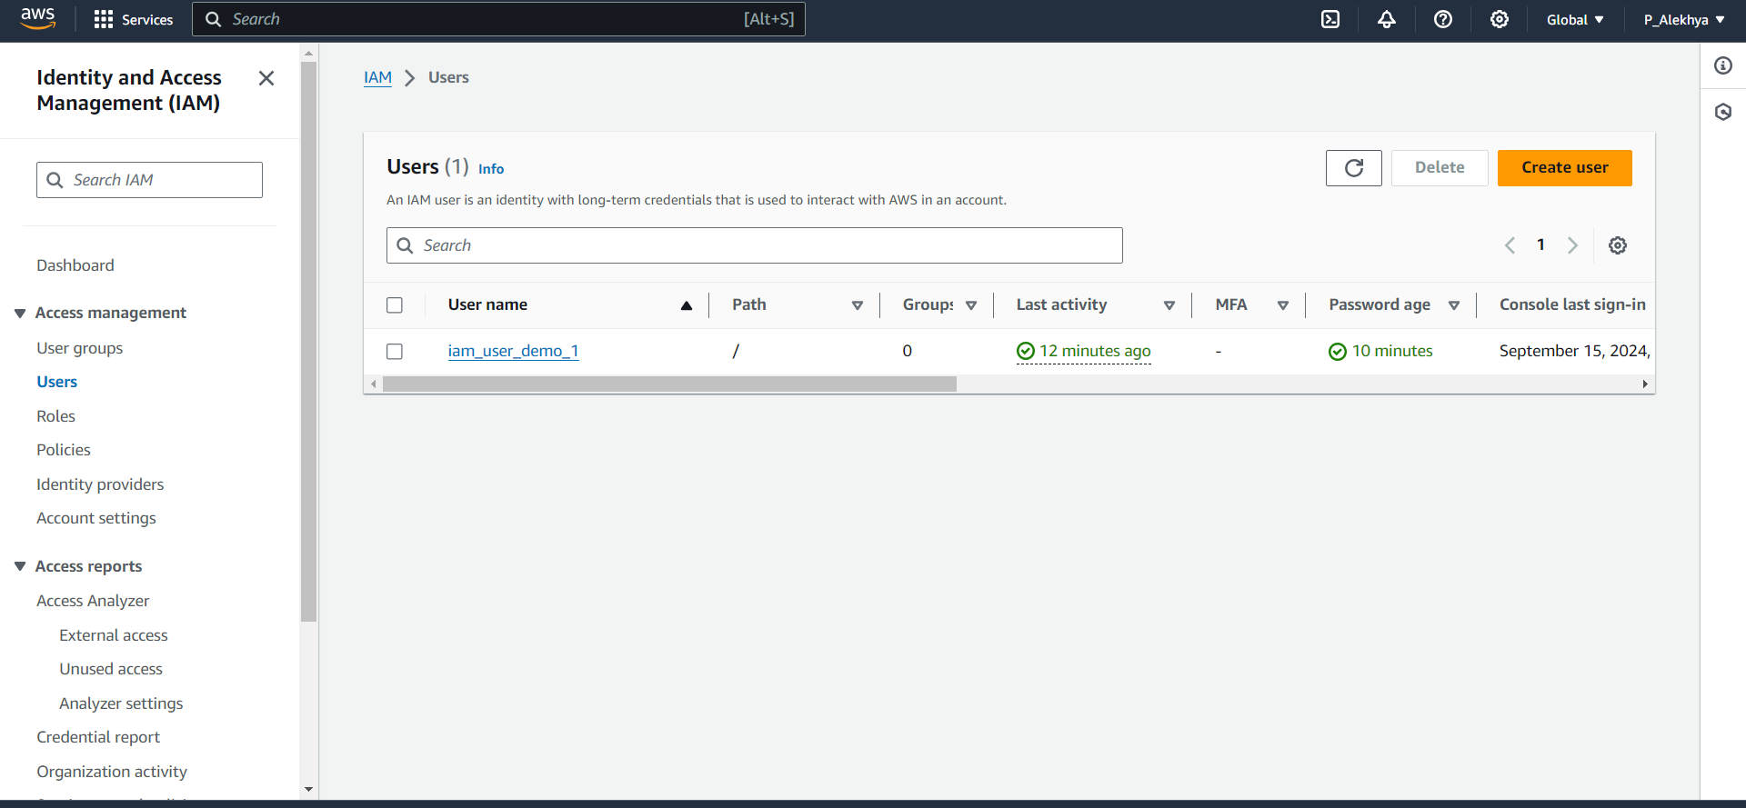

-The IAM Users dashboard, click on an user under user name in this case ‘iam_user_demo_1’ to give services access to it .  
**Note:** If you can’t find the user there, create an IAM user by clicking on 'Create user.' While creating the user, you can also assign the desired service permissions.

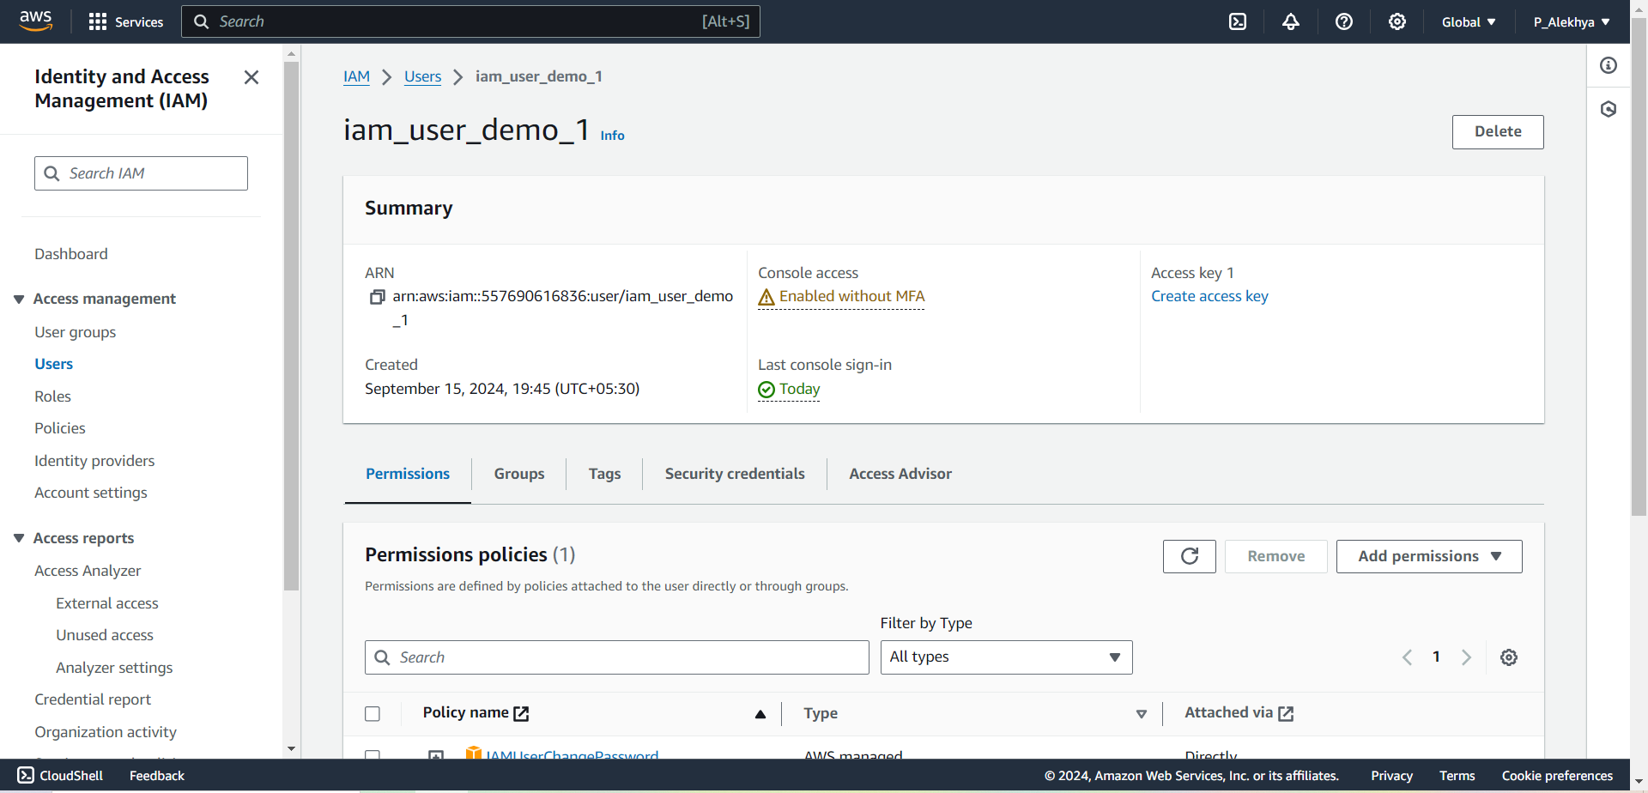

* An IAM user dashboard, displaying complete information about the user.

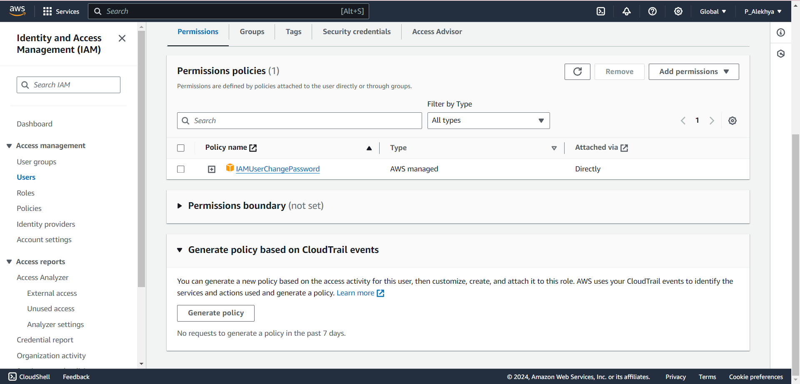

* Here we could find the existing permission policies and add new permissions.

1. **Attach the necessary permissions for both Amazon S3 and Amazon EC2 directly to the IAM user.**

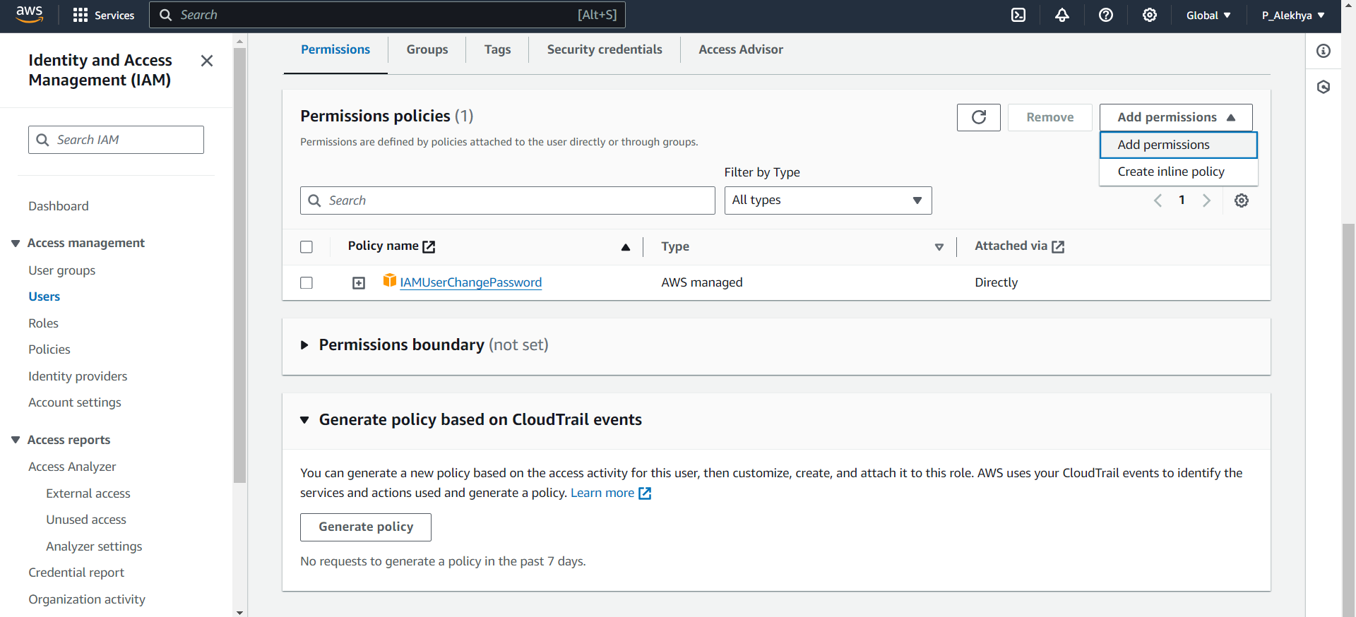

In the Permission Policies dashboard, click on 'Add permissions' to assign the desired permissions to the user."

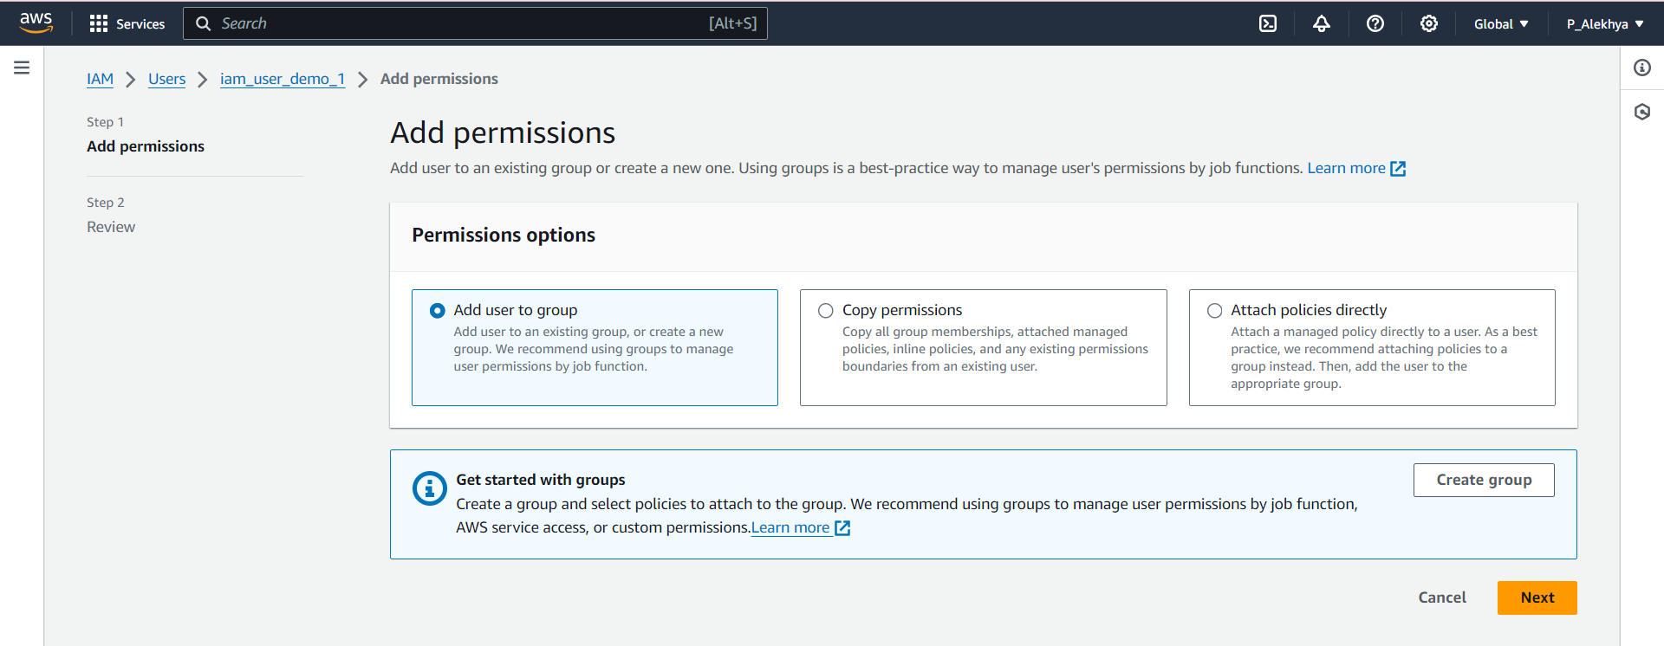

In the 'Add permissions' dashboard, navigate to 'Attach policies directly' to assign permissions.

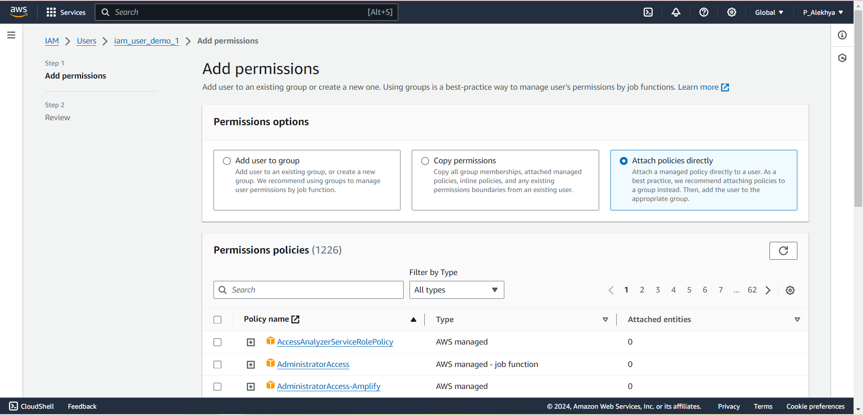

Then, in the Permission Policies section, search for the S3 service

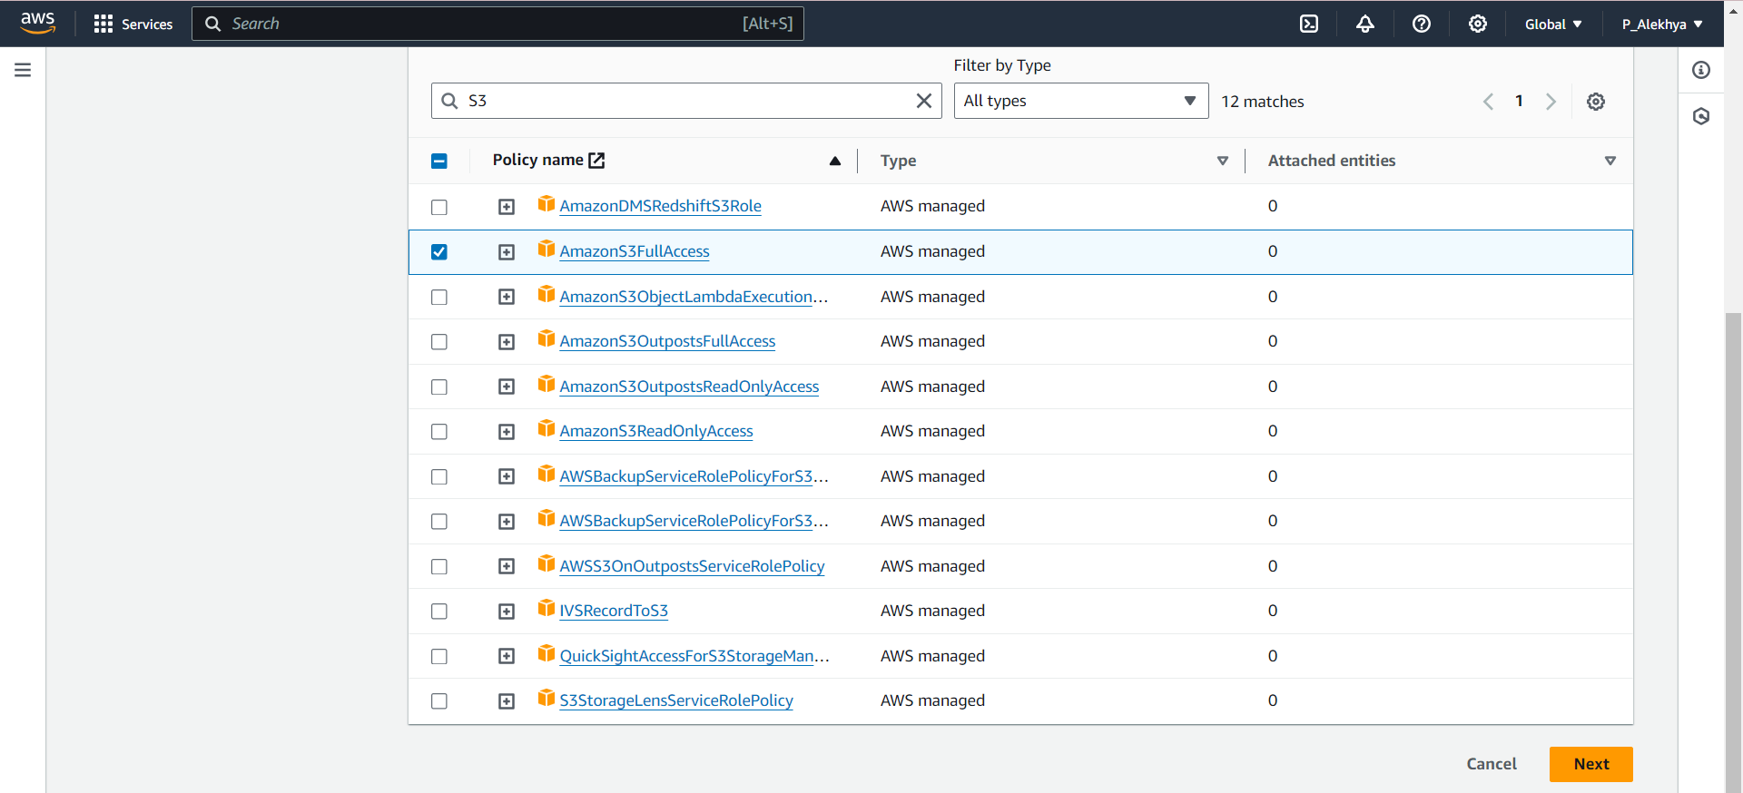

Select 'AmazonS3FullAccess' and click 'Next'.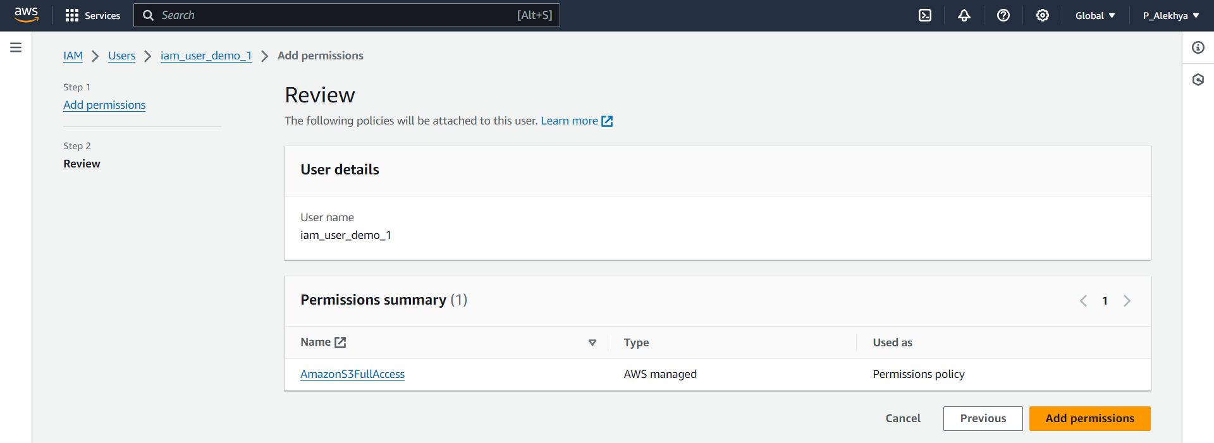

Review the user details and permissions summary, then click on 'Add permissions'

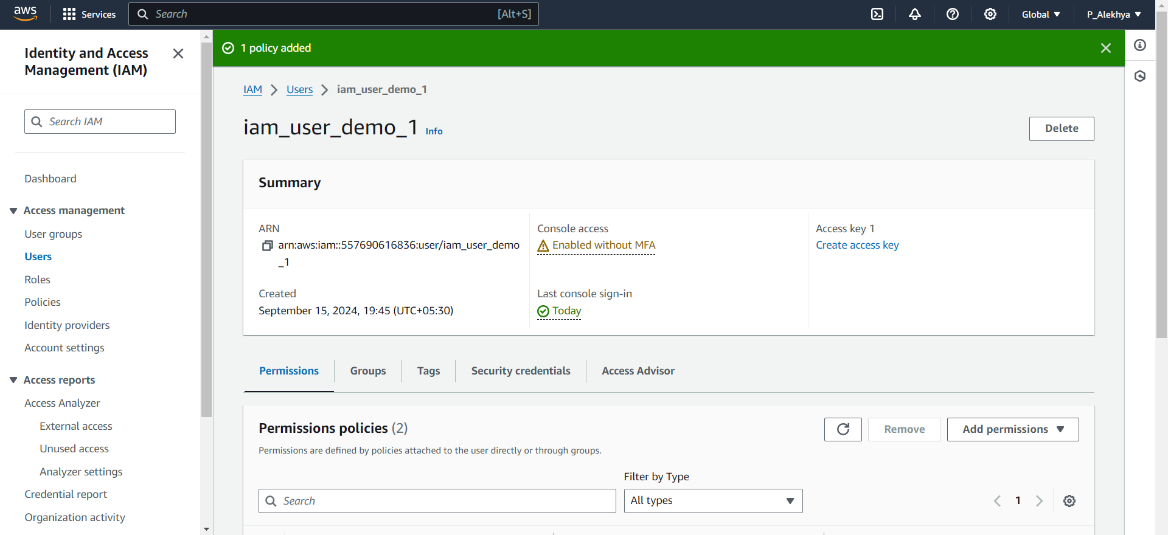

You will then be redirected to the IAM user dashboard

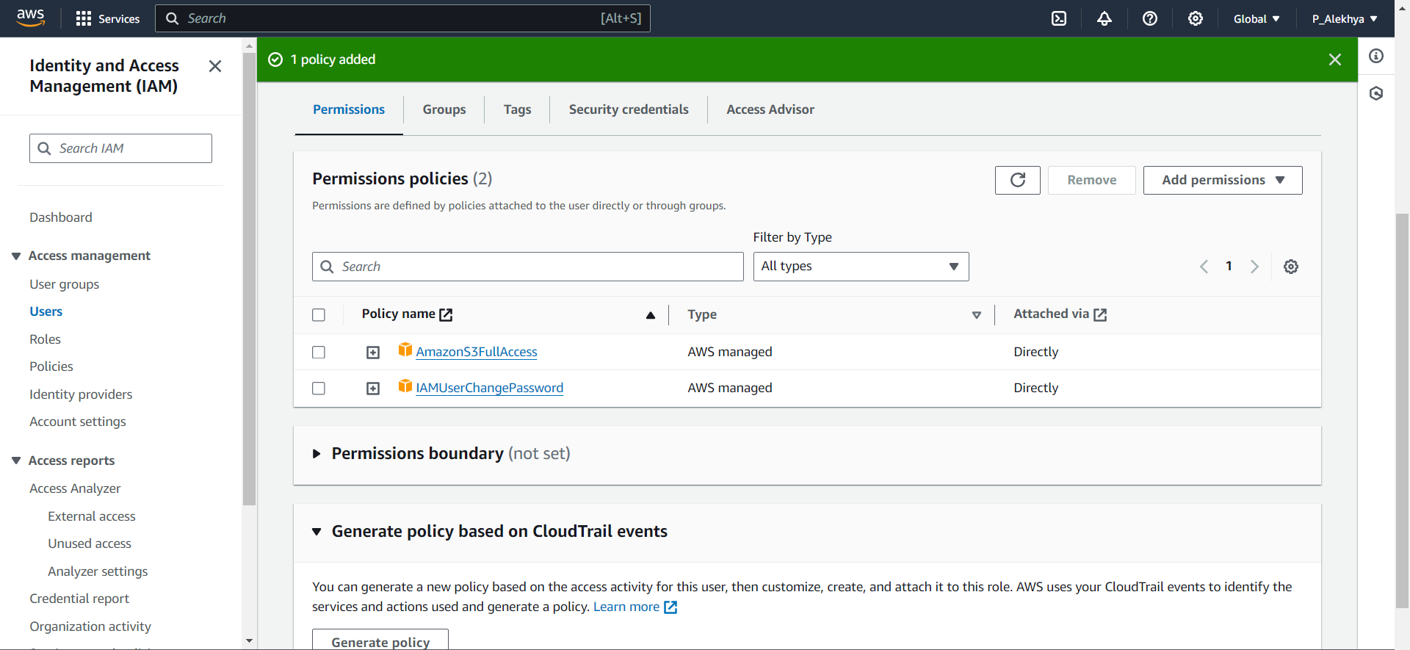

There, you can see that S3 has been added to the user account. You can follow the same steps to add the EC2 service by clicking on 'Add permissions'

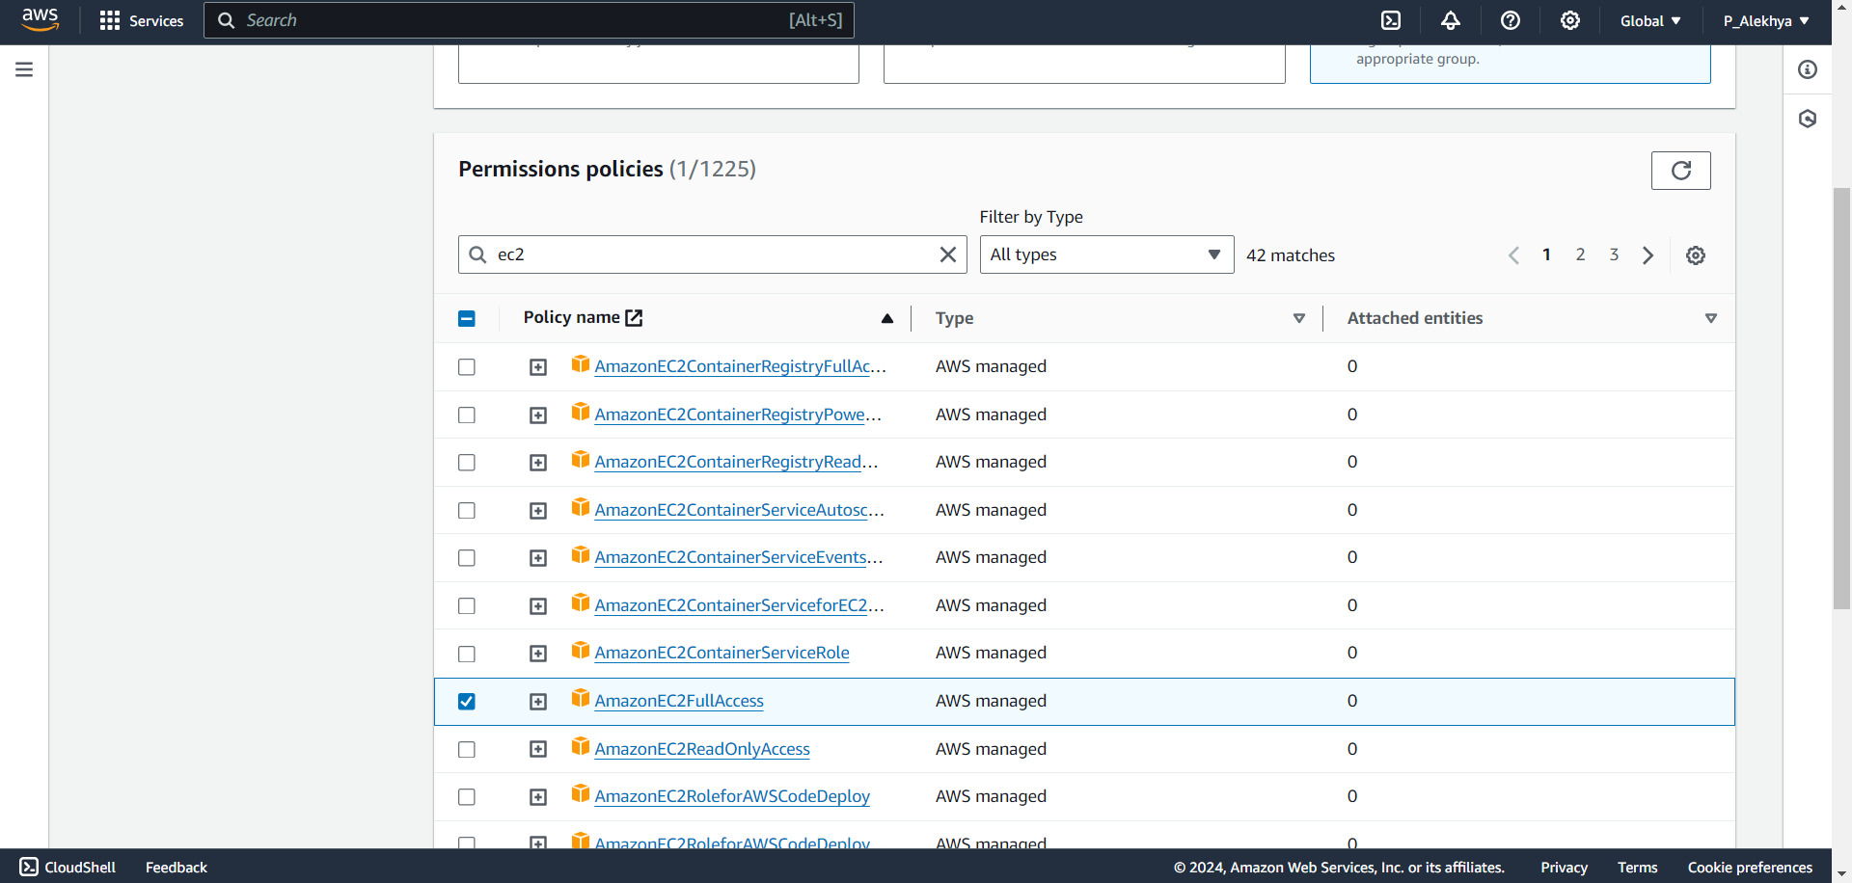

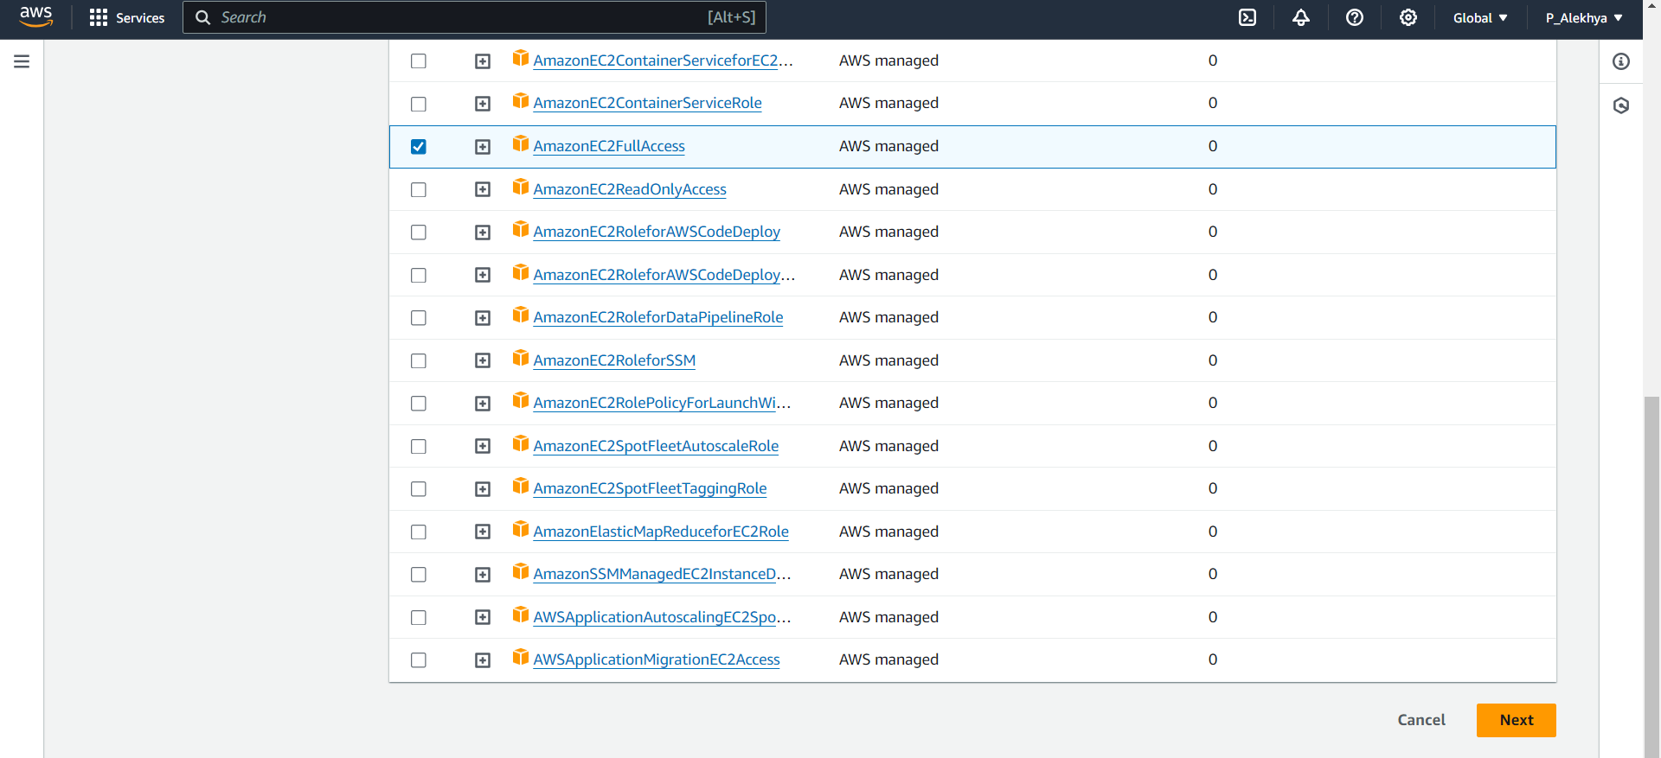

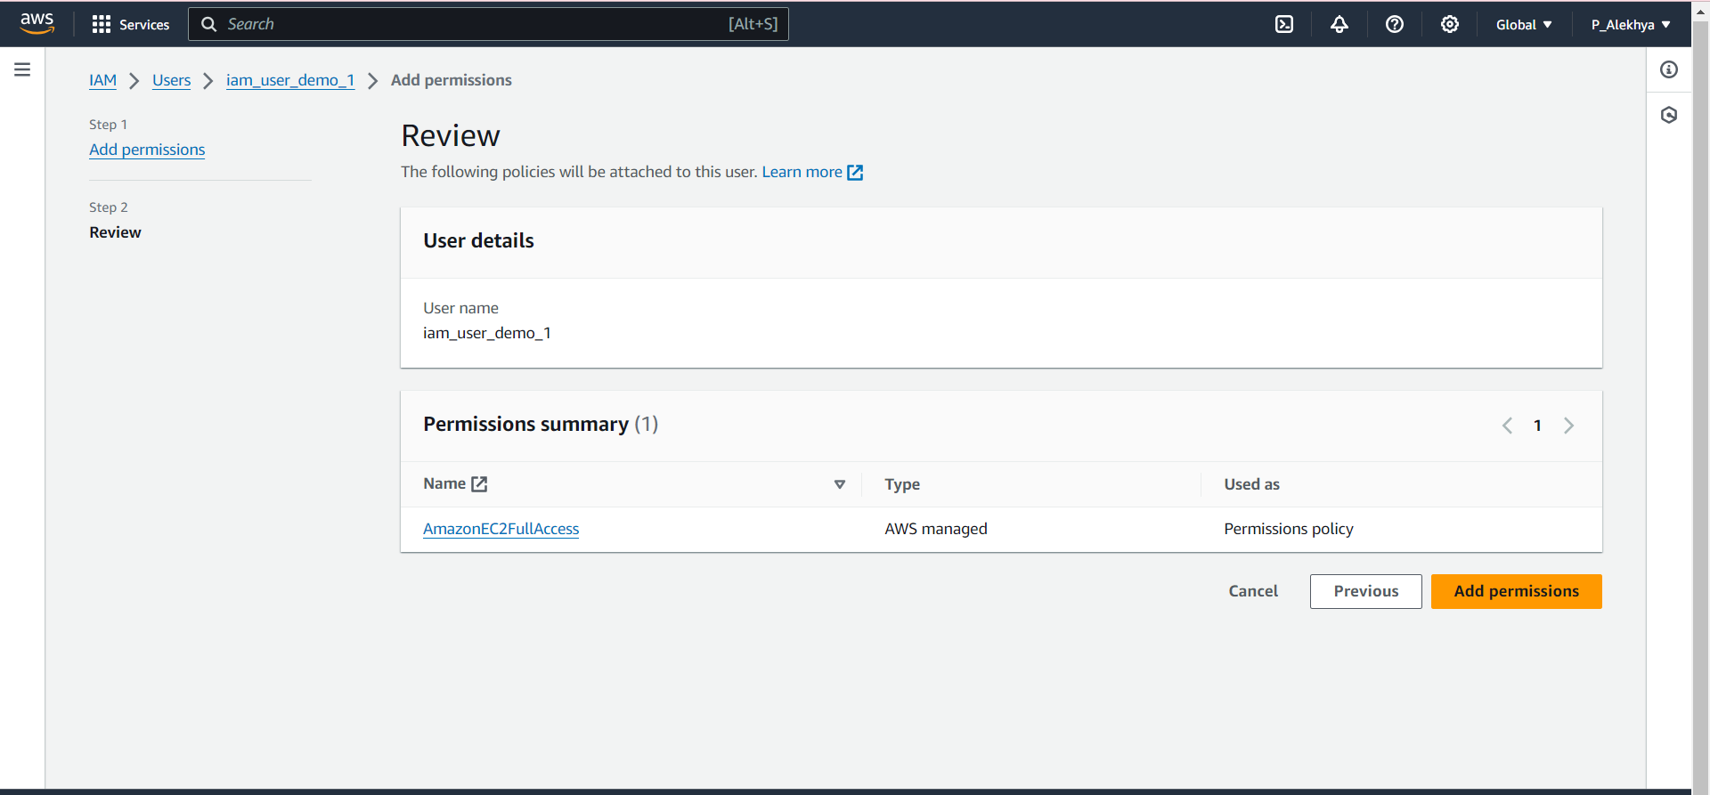

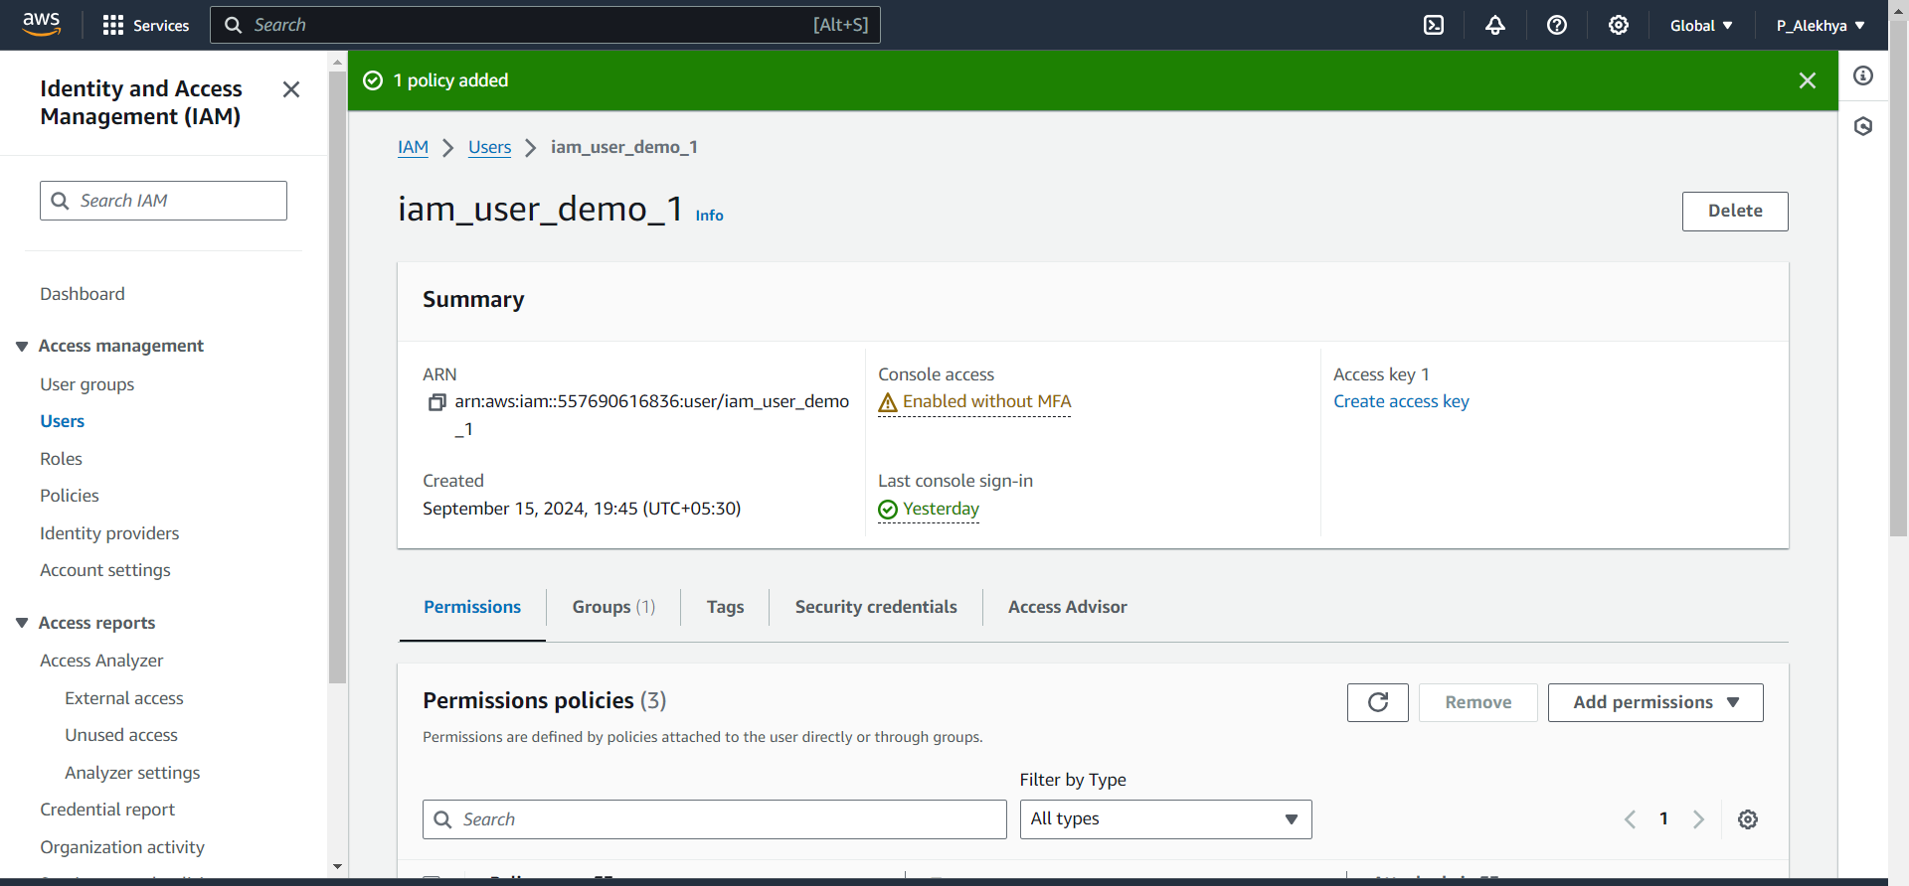

We have successfully added EC2 permissions to the IAM user, granting them the ability to manage and control EC2 resources. The user can now launch, manage, and terminate EC2 instances, as well as perform other EC2-related tasks as required.

1. **Ensure that the process has been successfully completed by confirming the user’s access to the required services.**

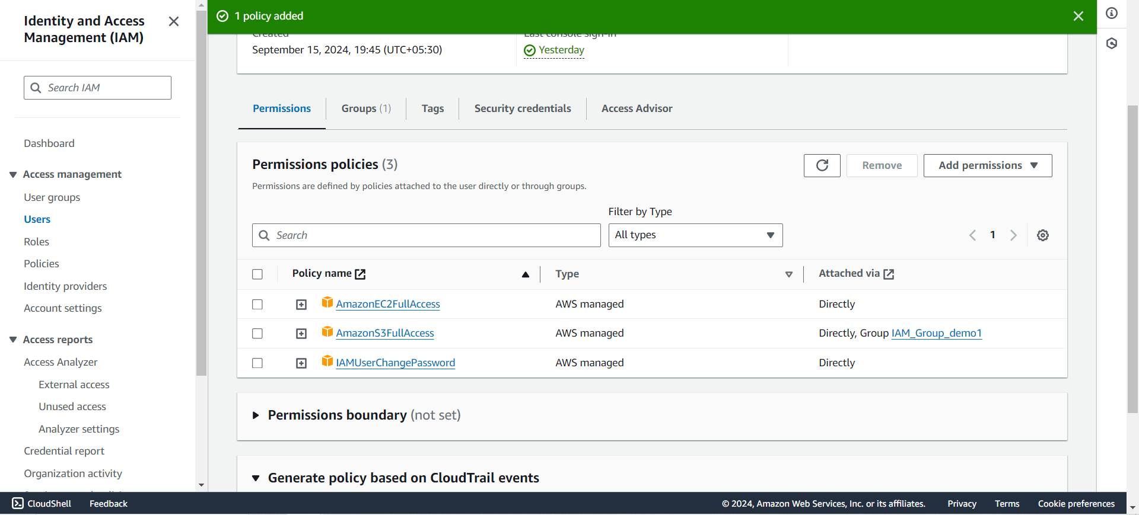

We have successfully added both Amazon S3 and EC2 permissions to the IAM user. The user now has full access to all Amazon S3 services, allowing them to create, manage, and delete S3 buckets, as well as perform tasks like uploading and downloading objects and setting access permissions. Additionally, with the EC2 permissions, the user can now manage EC2 resources, including launching, managing, and terminating EC2 instances. This setup ensures that the IAM user has the necessary access to both S3 and EC2 services for efficient resource management.

**Conclusion:**

By implementing a tailored IAM user system, MediaStream Studios has enhanced the security of its media assets while improving operational efficiency in managing Amazon S3 storage and Amazon EC2 processing tasks. This solution provides the production team with controlled access to these essential AWS services, minimizing risks and ensuring a flexible, scalable cloud environment that supports the growing demands of media production.